A DEEP TEMPORAL TRANSFORMER APPROACH FOR ALZHEIMER’S DISEASE DETECTION

Rajat Sharma | Milin Patel | Varun Deep
Department of Computer Science | Department of Computer Science | Department of Computer Science
VIT Bhopal University | VIT Bhopal University | VIT Bhopal University
Bhopal 466114, India | Bhopal 466114, India | Bhopal 466114, India
rajatsharma.022805@gmail.com | milinp551@gmail.com | varundeep1706@gmail.com
Kopal Khare | Tanishka Shandilya | Mohak Varshney
Department of Computer Science | Department of Computer Science | Department of Computer Science
VIT Bhopal University | VIT Bhopal University | VIT Bhopal University
Bhopal 466114, India | Bhopal 466114, India | Bhopal 466114, India
kopalkhare2@gmail.com | tanishka18shandilya@gmail.com | varshneymohak2005@gmail.com

Abstract - The performance of automatic Alzheimer’s disease detection using traditional machine learning methods greatly depends on the choice of meaningful descriptive features derived from the MRI scans of the brain. Identification of such features requires domain-specific expert knowledge and is not a straightforward process. This paper studies the feasibility of using a transformer by presenting a deep temporal transformer (DTT) framework designed for accurate binary screening of dementia. Compared to traditional machine learning methods, the proposed DTT treats the MRI data as a temporal sequence of two-dimensional slices to capture long-range dependencies across inter-slice context. The architecture integrates a ResNet34 spatial feature extractor with a Temporal Progression Transformer (TPT). To optimize performance, we employ the Brown Bear Optimization (BBO) algorithm to tune feature projection dimensions. The performance of our DTT is compared to two well-known machine learning methods - the support vector machine (SVM) and the extreme learning machine (ELM). The comparison shows that our approach treats the 32 slices as a single, cohesive patient-level sequence, unlike some existing methods that treat each of the 32 brain slices as an independent data point (inflating the dataset and losing critical context). More importantly, the proposed approach is general and can be applied to other biomedical or biological datasets.

KEY WORDS
Deep Temporal Transformer, Brown Bear Optimization, Alzheimer’s, Digital Pathology.

Introduction

Neuroimaging has become very important for modern clinical diagnostics, particularly with the rise of Magnetic Resonance Imaging (MRI) for identifying the changes that occur in the brian. The analysis of brain data has become very sophisticated with improvements in computational power and digital acquisition [9]. The MRI scans have become a vital tool for high throughput screening of brain related disorders, complementing the qualitative evaluations performed by radiologists [8], [10]. A primary application of this technology is the early detection of Alzheimer’s disease, where identifying the changes in the brain is critical for patient outcomes.

To assess MRI scans quantitatively using computers, it is necessary to identify specific regions of interest (ROI) within the brain, such as the hippocampus or cortical thickness. Most of the conventional methods require manual annotation or rely on 2D slice-by-slice analysis [11]. In these standard approaches, each individual slice of a 32-slice MRI scan is often treated as a separate data point. This practice not only increases the dataset artificially but also fails to capture the essential relationships between the slices and the holistic anatomical progression of the disease within a single patient.

The latest progress in image processing and machine learning makes it possible to localize these neuroanatomical markers with minimal human intervention. Conventional machine learning techniques, such as Support Vector Machines (SVM) [4] and Extreme Learning Machines (ELM) [5], have been used for this task till now. However, these methods are limited in their ability to process raw volumetric data. They require careful engineering and domain specific knowledge to design feature extractors that transform raw pixels into suitable internal representation. The efficiency of these classifiers is restricted by this manual feature selection process, which is not always intuitive.

To overcome these limitations, a deep learning approach, specifically the Deep Temporal Transformer (DTT) is proposed to automatically discover the hierarchies of representation needed for classification. The key advantage of our deep learning framework is that these layers of features are learned directly from the data. Unlike 2D Convolutional Neural Networks (CNNs) that analyze isolated slices, our model acknowledges that a single patient consists of a sequence of 32 brain slices. By combining these slices into a unified patient-level sequence representation, the model can learn complex slice-level spatial and inter-slice temporal functions that represent the whole brain structure [2].

In this study, we investigated the use of a Deep Temporal Transformer (DTT) for automated binary Alzheimer’s screening (Demented vs. Non-Demented). We present an architecture that integrates a ResNet34 spatial extractor [1] with a Temporal Progression Transformer to analyze the full 32-slice sequence as a single patient-level entity. To optimize this complex pipeline, we utilize the Brown Bear Optimization (BBO) algorithm [3] to tune feature projection dimensions. We compare the classification performance of this patient-level multi-slice approach against traditional 2D slice-based methods. Our results, achieving an F1-macro score of 0.82 on our validation setup, demonstrate that patient-level multi-slice analysis provides a more biologically grounded and potentially more clinically useful alternative to standard 2D diagnostic techniques.

Methodology
Deep learning architectures are formed by the composition of multiple linear and non-linear transformations of input data, with the goal of yielding more abstract and ultimately more useful representations. These methods have demonstrated outstanding performance in complex computer vision and pattern recognition tasks. The architecture proposed in this study represents an evolution of traditional convolutional networks, specifically designed to address the spatial and sequential complexities of neuroimaging.

A defining characteristic of our approach is that feature extraction is integrated directly into the learning process. Unlike traditional methods that treat each of the 32 MRI slices as an independent data point, our model acknowledges the inherent inter-slice structure of the brain. While existing literature often classifies single 2D instances, our framework treats the 32-slice sequence as a unified patient-level sequential input, allowing the network to find an appropriate representation of the patient's brain in terms of multi-level slice-level spatial and inter-slice temporal feature maps.

In this section, we first introduce the Deep Temporal Transformer (DTT) architecture and the specific spatial-to-sequential pipeline. After that, the integration of the ResNet34 spatial extractor [1] with the Temporal Progression Transformer [2] is presented for the binary dementia screening task. Finally, we discuss the application of the Brown Bear Optimization (BBO) algorithm [3], a meta-heuristic used to tune the feature projection dimensions and enhance the model's predictive robustness.

2.1 Data Preprocessing and Patient-Level Stratification

To avoid data leakage, which artificially increases performance metrics for medical image data, we implement a Patient-Level Stratified K-Fold cross-validation with 2 folds (with automatic adjustment if required by class counts). The dataset is binarized into two classes: ‘Demented’ and ‘Non-Demented’. For each patient, the MRI images form a sequence up to a maximum timestep T = 32. If there are less than T images for a patient, zero padding is used. At the same time, a Boolean mask is created to ensure that the attention mechanism of the transformer network ignores these padded timesteps during computation.

2.2 Spatial Feature Extraction (Slice-Level Encoder)

We make use of a pre-trained ResNet34 architecture [1] as the underlying spatial encoder, thus avoiding the need for manual feature extraction. The fully connected classification layer of the ResNet is replaced by a linear projection layer. The latter compresses the original feature dimensionality of 512 to a dynamically optimized reduced dimensionality, denoted as d_{model} .

The spatial feature representation for a given input slice x_{t} at a particular time step t is defined as:

F_{t} = W_{proj} (ResNet(x_{t})) + b_{proj}

2.3 Temporal Progression Transformer
For modeling the progression of dementia, a Transformer architecture is utilized [2], and the spatial features F = {f₁, f₂, ..., f_{T}} are fed into this architecture using a Transformer encoder. A learnable classification token f_{cls} is prepended to the spatial features, and a positional encoding matrix P is added to retain the order of the scans.

Table 1: DTT Architecture Layout
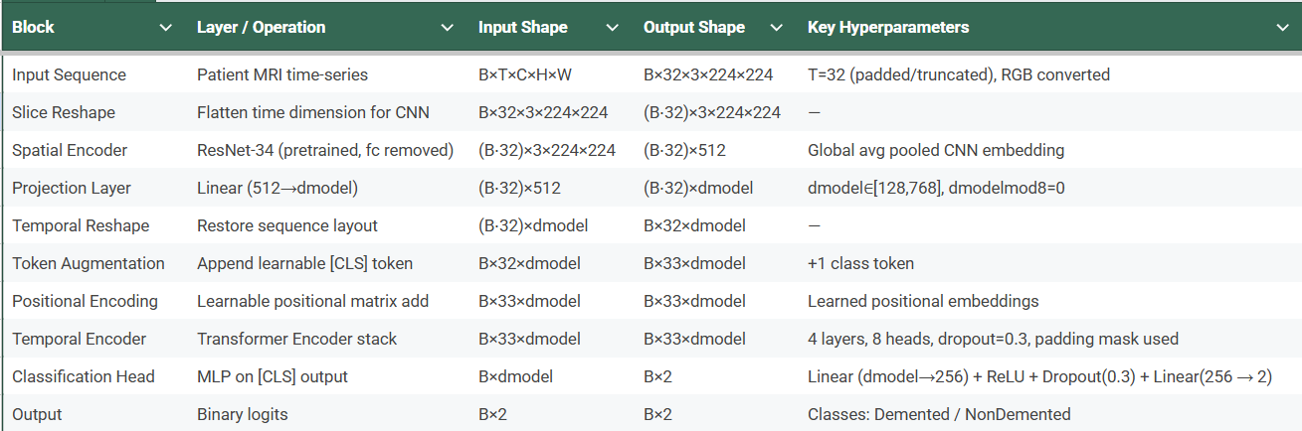

The self-attention mechanism is used to find the correlation between different scan days:
$Attention\left(Q,K,V\right)=softmax\left(\frac{QK^{T}}{\sqrt{d_{k}}}\right)V$
where Q, K, and V are query, key, and value matrices respectively, and d_{k} is a scaling factor based on the number of attention heads (set to 8). The proposed architecture uses 4 transformer layers implemented via PyTorch framework [7]. The output corresponding to the classification token f_{cls} is fed into a Multi-Layer Perceptron (MLP), which is composed of a linear layer, ReLU activation, dropout (p=0.3), and a linear classification layer.

2.4 Brown Bear Optimization (BBO)

The selection of an optimal dimension for projection (d_{model}) has a direct effect on the transformer's representational capacity.

We utilize a Brown Bear Optimizer (BBO) algorithm [3] to efficiently explore the search space. The BBO algorithm uses a population size of 8 candidates to iteratively explore the dimension of interest, which lies in the range of [128, 768], and it must be divisible by 8, which represents the number of attention heads. During the optimization phase, each candidate architecture is subjected to an evaluation period of 5 epochs. The objective function used here is maximization of Validation F1-Macro.

Table 2: BBO-Based Search for Optimal Projection Dimension

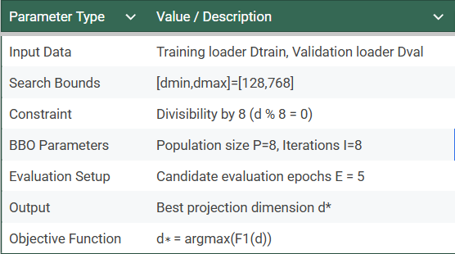

- EXPERIMENTAL SETUP AND RESULTS

The training and evaluation of the model were conducted using PyTorch [7] and an NVIDIA GPU. The optimization process was achieved using the Adam optimizer [6] with a constant learning rate of 5 X 10⁻⁶ and a weight decay of 0.001.
We used a standard Cross-Entropy loss function:

$L= -\frac{1}{N}\sum_{i=0}^{N}{}loglog \left(\frac{expexp \left(x_{i,y_{i}}\right) }{\sum_{c=1}^{C}{}exp⁡(x_{i,c})}\right)$

To reduce the problem of class imbalance with the small batch size B=2, a class-alternating heuristic sampler was used, called BalancedBatchSampler. Moreover, gradient clipping with a maximum norm equal to 1.0 was used to avoid exploding gradients during the transformation process. An early stopping method was used with the Validation F1-Macro score as the metric to stop the training process if there was not an improvement greater than or equal to 0.001 for 20 epochs.

3.1 Evaluation Matrices

Given the differences in class distribution, we are using F1-Macro score as our primary metric, along with Accuracy, ROC AUC, and PR AUC. F1-Macro calculates the unweighted mean of F1 scores for all classes, ensuring that the minority class is well represented:
${F1}_{macro}= \frac{1}{C}\sum_{i=1}^{C}{}2\left(\frac{{Precision}_{i }× {Recall}_{i}}{{Precision}_{i}+ {Recall}_{i}}\right)$

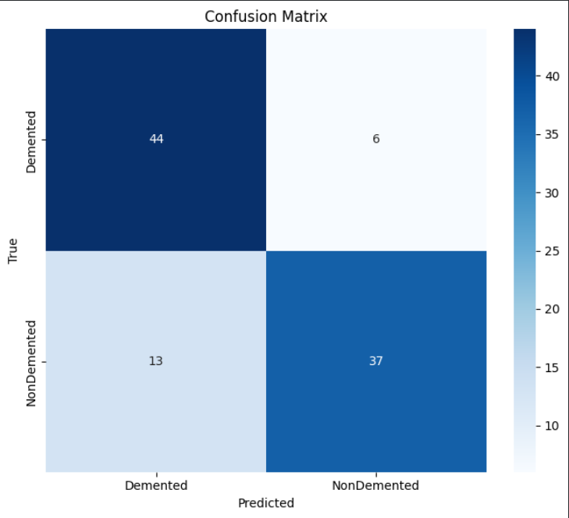
Figure I

The above figure is a confusion matrix for our model which points to a model which can detect Alzheimer’s with minimal misclassification.

3.2 Optimization Results

The BBO algorithm [3] efficiently explored the projection dimension search space over 8 iterations.

As illustrated in Figure II, the algorithm explores various dimensions and converges to an optimal dimension with the best f1score(best reduced dimension = 144).

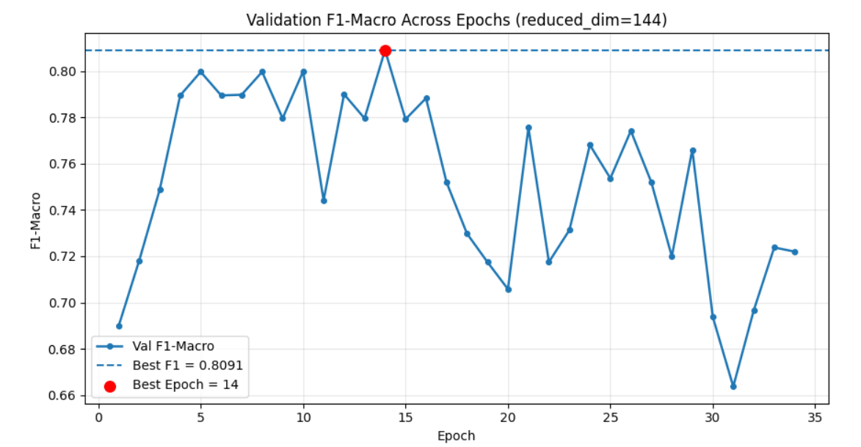
Figure II: Reduced Dimension vs F1 score

3.3 Classification Performance
The final DTT system was subjected to full training after the optimal dimension was derived using the BBO.
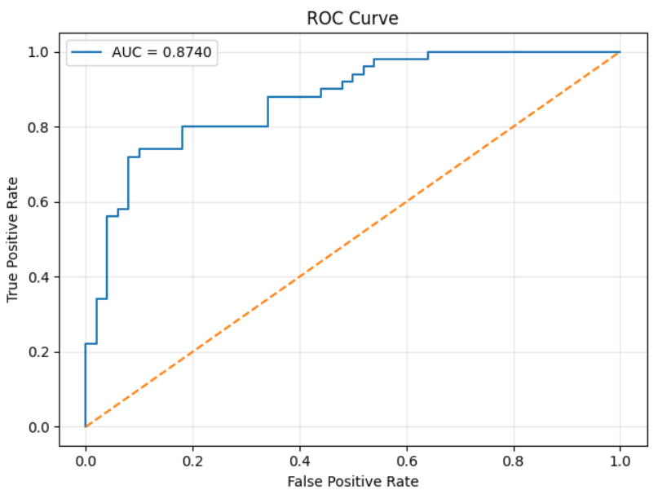 Figure III: True Positive Rate vs False Positive Rate
The above figure shows us the strong ability of a model to differentiate between classes with high true positive rates achieved as compared to the low false positive rates

Figure IV: Epoch vs F1 score
The below figure shows the balance between precision and recall. The model shows reliable precision while predicting correct labels thus showing robustness in Alzheimer’s detection.
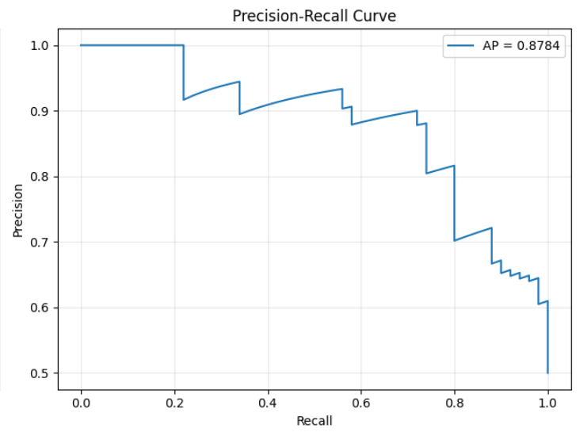
Figure V: Precision-Recall Curve

The training curves (Figure III & IV) show the convergence of the model. The early stopping technique was effective in terminating the training when the improvement on the validation plateaued, thus preventing overfitting with the help of the 0.3 dropout rate.

The confusion matrix and the PR-AUC plot show the efficacy of our temporal attention mechanism in maintaining a high level of precision and recall when it comes to identifying the 'Demented' class of patients.

Conclusion
We introduced a Deep Temporal Transformer (DTT) designed to automate the detection of Alzheimer’s disease. Our model combines a ResNet34 feature extractor with a Temporal Progression Transformer to move beyond traditional methods, like SVM or ELM, which often view MRI slices in isolation. Instead, our approach treats a 32-slice MRI sequence as a single, unified patient story. This allows the AI to recognize how different parts of the brain relate to one another, much like how a radiologist looks at the whole picture to identify signs of atrophy. By using Brown Bear Optimization (BBO) to fine-tune the system, we achieved a strong F1 score of 0.82. Because the DTT learns directly from the data without needing manual expert input, it can be easily adapted to other complex biological datasets. Moving forward, we plan to explore deeper neural networks, expand our focus to multi-class dementia stages, and apply this framework to long-term health tracking.

Dataset :-
https://www.kaggle.com/datasets/marcopinamonti/alzheimer-mri-4-classes-dataset

Code :- https://colab.research.google.com/drive/1CbBRri9qIJt5FSzlhNYcJFl9KHoe28ka?usp=sharing

References
- K. He, X. Zhang, S. Ren, and J. Sun, Deep residual learning for image recognition, Proceedings of the IEEE Conference on Computer Vision and Pattern Recognition (CVPR), 2016, 770–778.
- A. Vaswani, N. Shazeer, N. Parmar, J. Uszkoreit, L. Jones, A. N. Gomez, L. Kaiser, and I. Polosukhin, Attention is all you need, Advances in Neural Information Processing Systems (NIPS), 30, 2017, 5998–6008.
- T. Prakash, P. P. Singh, V. P. Singh, and S. N. Singh, A novel Brown-bear optimization algorithm for solving economic dispatch problems, Advanced Control & Optimization Paradigms for Energy System Operation and Management, 2023, 137–164.
- C. Cortes and V. Vapnik, Support-vector networks, Machine Learning, 20(3), 1995, 273–297.
- G.-B. Huang, Q.-Y. Zhu, and C.-K. Siew, Extreme learning machine: Theory and applications, Neurocomputing, 70(1-3), 2006, 489–501.
- D. P. Kingma and J. Ba, Adam: A method for stochastic optimization, arXiv preprint arXiv:1412.6980, 2014.
- A. Paszke, S. Gross, Francisco Massa, A. Lerer, J. Bradbury, G. Chanan, etc., PyTorch: An imperative style, high-performance deep learning library, Advances in Neural Information Processing Systems (NeurIPS), 32, 2019, 8024–8035.
- C.R. Jack Jr, M.A. Bernstein, N.C. Fox, P. Thompson, G. Alexander, D. Harvey, etc., The Alzheimer's Disease Neuroimaging Initiative (ADNI): MRI methods, Journal of Magnetic Resonance Imaging, 27(4), 2008, 685-691.
- S. Al-Janabi, A. Huisman, and P.J. Van Diest, Digital pathology: current status and future perspectives, Histopathology, 61(1), 2012, 1–9.
- A.N. Basavanhally, S. Ganesan, S. Agner, J.P. Monaco, M.D. Feldman, J.E. Tomaszewski, etc., Computerized image-based detection and grading of lymphocytic infiltration in HER2+ breast cancer histopathology, IEEE Trans. Biomedical Engineering, 57(3), 2010, 642–653.
- S. Akbar, L.B. Jordan, C.A. Purdie, A.M. Thompson, and S.J. McKenna, Comparing computer-generated and pathologist-generated tumour segmentations for immunohistochemical scoring of breast tissue microarrays, British Journal of Cancer, 113(7), 2015, 1075-1080.

